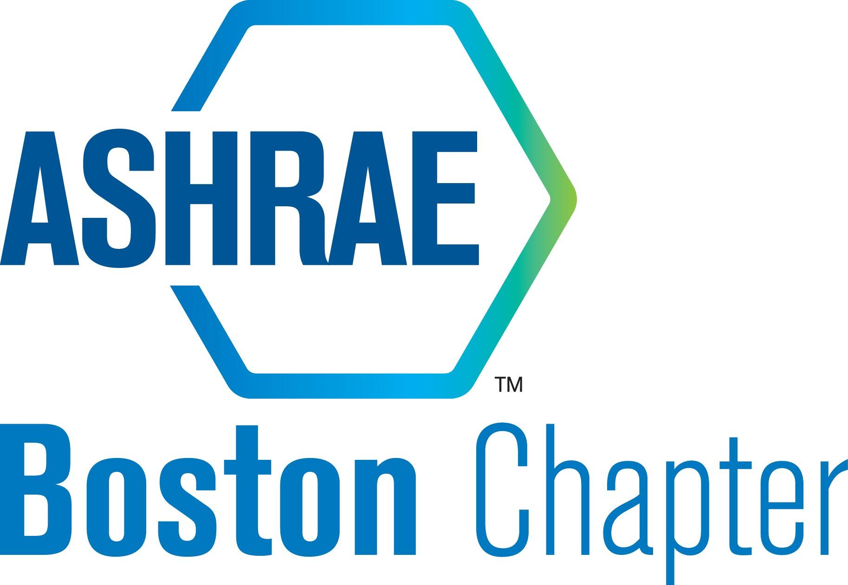 ASHRAE – Boston Chapter (ABC) Board of Governors
September BOG Meeting Agenda

Date: | September 14, 2021, 4:30pm
Name: | September Board of Governors’ Meeting
Attendees: | Will C, Lance B,  Attendance was not taken rigorously, but a quorum was present.
Distribution: | Attendees, BOG, Officers
Item No. | Item Description | Action/Resp.
1.0 | Opening Remarks & Introductions
2.0 | Old Business
2.1 | 1. In person events for 2021-22  - Any ideas for a new downtown location for meetings?  - Da Vinci meeting rooms  - Convene  - Northeastern Conference  No action taken  - S Rosen provided alternate Waltham location. Waltham Woods, will have 75 person dinner availability & av equipment for virtual hybrid meetings. Eventual 100 person when things are better. Would need a possible 6 month contract with them.  Dates reserved at Embassy suites: Oct 13 and Nov. 16 | W. Cunningham / L. Rowe / E. Edman
2.3 | Moving meetings to noon to increase participation  No action taken
2.4 | Research Promotion:  - Succession plan for this year  Tabled. Will discuss with Vineet. | W. Cunningham / Vineet Nair
2.6 | Student Activities  - Yuka is no longer an ASHRAE member so Steve will be the chair for this year  Rosen appointed. No vote needed. | S. Rosen
2.7 | YEA  - Update  Axe throwing event approved | G. Foley
2.8 | Chapter financial report | L. Rowe
2.9 | CTTC:  - Succession Plan for this year – Will C handled the PAOE for this month  - Distinguished Lecturer for this year | W. Fisher / Vineet Nair
2.11 | Website Update | L. Desmarais
2.12 | History Update  Historian not in attendance | E Edman
2.13 | DiA –  - Future events for the year?  No decision made | E Norquist
3.0 | - 2021-2022 Planning
3.1 | Basecamp –  - Update contact info on 20-21 spreadsheet: https://public.3.basecamp.com/p/VPQKZ8kv9dpH5WRcL6gcs15o  - Will has a list of email alias’ and will be updating those  - Meeting calendar: https://public.3.basecamp.com/p/Qjnsa6smzP7NHuDaWqQo23D5 | All
3.2 | Current Schedule Ideas (in progress)  - Main Meetings & Promotional Nights – No updates  - YEA  - Axe Throwing scheduled for 10/7  - Special Events  - Goal: (2) events  - Diversity in ASHRAE  - Goal: (1) or (2) events?  - Golf Outing – Secure date for next year. Need new golf committee  Will Malia and Nick Roth left  - Product Show  - We need a new location – Update | W. Cunningham  All
3.3 | Things to do  - Meeting Calendar updates  - Need to fill empty chair spots  - Government Affairs – Will still current chair but we should find a candidate for succession No successor identified  - Reception/Attendance Committee – Approve of Drew Brown of position Sales engineer, couple years out of school.  - Sustainability – Lance is temp chair until we find someone for seat. Advertise as open.  - Auditing – Need to form a committee  - Product Guide – Leo Araujo – to be confirmed next month  - CRC participation  - Contact RVC if you cannot participate  - CRC is this weekend for everyone that is  - BOG to watch Sexual Harassment Prevention videos:  https://www.youtube.com/watch?v=sL7LwBsV9bM  https://www.youtube.com/watch?v=1za7gs9S2H0  - Audit last year’s finances  - Annual budget approval by September 15th  - Budget attached for review  - Approved  - Donate leftover sponsor funds to RP before the end of the year  Plan put in place to allow for companies to be represented for the 2021-2022 year for their records and for our upcoming fiscal year of July 2021- June 2022  Tabled
5.0 | New Business
5.1 | Newsletter  Articles due 9/21
6.0 | Adjournment

