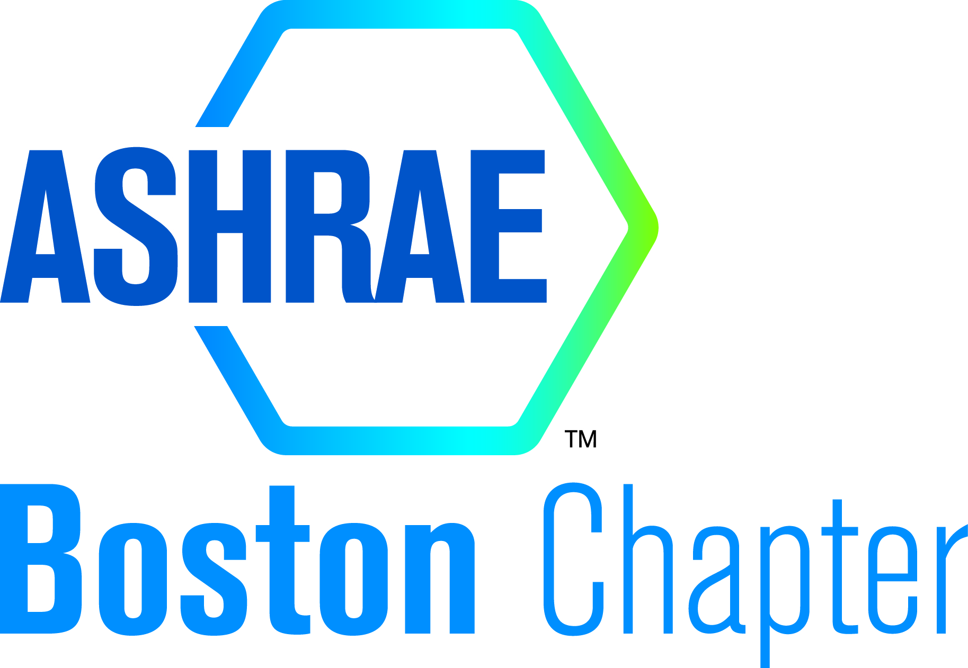 ASHRAE – Boston Chapter Board of Governors
Meeting Minutes

Meeting Date: | January 11, 2022
Meeting Name: | January Board of Governors Meeting
Attendees: | Will Cunningham, Eric Edman, Will Fisher, Liz Desmarais, Daniel Diorio, Deanna Adkison, Amy Gebhardt, Ben Almond, Allison Guttadauro, Mallory Epstein, Lucas Rowe, T Jones, Josephine Wendroth, Kiersten Washle, Drew Brown, Lance Brown
Distribution: | Officers, Board of Governors, Committee Chairs
Item No. | Item Description | Action/Resp.
1.0 | Opening Remarks | Will C.
1.1 | Welcome and introductions
2.0 | Old Business
2.1 | Approve August, September, & October Meeting Minutes | BOG/Officers
2.2 | Treasurer’s Report  - We own a projector – backroom at BR+A (Required by accountant)  - Approved YEA budget increase. | Lucas R.
2.3 | Product Show  - Had an offline meeting before BOG meeting.  - Can’t cancel Quincy Marriot – Will have to pay $10k/5k for food.  - Can postpone by 6 months.  - Need more involvement in the product show committee.  - Move product show to Fall ’22.  - Pandemic will cause engineers to not show up for the show.  - Will have increased motivation among the board to get involved.  - Will help by not receiving funds from the vendors which will have to be returned.  - We will have to produce newsletters and other communications during the summer months for the Fall product show – will be outside the norm and BOG will be largely inactive.  - Ideally find a date in November instead of October.  Voted by BOG:  Postpone - 13  Keep in April – 1 | Eric E. / Amy G.
2.4 | - BOG/Officers to watch Sexual Harassment Prevention videos  See attached link(s)  https://www.youtube.com/watch?v=sL7LwBsV9bM  https://www.youtube.com/watch?v=1za7gs9S2H0  - Please let me know when you have watched videos | BOG / Officers
2.5 | YEA / DIA Webinar  - Review event  - Tabled for next month | Matt H. / Gage Foley
3.0 | New Business
3.1 | Attendance | Drew B.
3.2 | Chapter Technology Transfer Committee (CTTC)  - We need to add a remote meeting for April in place of the product show.  - April 12th.  - Topic tabled for now. | Will F.
3.3 | Government Affair Committee (GAC) | TBD
3.4 | Historian | Eric E.
3.5 | Honors & Awards | Bob P.
3.6 | Membership Promotion (MP)  - Asked by RVC to hold a MP battle.  - Which company can have more member join (percentage wise), will be announced in this month’s newsletter?  - Reaching out to all members who are delinquent every month.  - Josephine Wendroth is on the MP committee. | Kiersten W. / Tim D.
3.7 | Newsletter  - Newsletter due 1/25.  - Need to add RP section  - Add sponsorship details. | Allison G.
3.8 | Nominating | Bob P.
3.9 | Professional Development  - Do we need this as its own Chair? I have someone that may be interested in this | Will F.
3.10 | Publicity | Liz D.
3.11 | Refrigeration | Steven T.
3.12 | Research Promotion (RP)  - Sponsorships sent out. Gold sold out. 13 Silver remaining. 1 Platinum remaining  - Met 100% of goal and exceeded the amount by $2k. Reason was left over funds from sponsorship during the 20-21 ASHRAE year.  - Will have higher goal for 22-23. | Vineet N.
3.13 | Sustainability  - Establish a committee | Kiersten W.
3.14 | Special Events  - No special events this year due to the pandemic. | Amy G.
3.15 | Student Activities (SA) | Steve R.
3.16 | Website | Liz D.
3.17 | Diversity in ASHRAE (DiA)  - April could be a potential event for DiA | Erica N.
3.18 | Young Engineers in ASHRAE (YEA) | Matt H. / Gage Foley
3.19 | Golf Committee  - Price has been raised from $15,250 to $21,600 total  - May need to consider upping the foursome price  - Contract with Granite Links -confirmed  - Still working to get sponsors on board  - Will have verbiage in the newsletter for next month.  - Same photographer as last year. | Trevor Jones / Ben Almond
3.20 | February Meeting  - Separate Tech speaker and Main meeting – both confirmed  - Main meeting is PDH approved. | E. Edman
3.21 | Employer Recognition – Need to plan an event for this year. | William C.
3.22 | Presidential Award of Excellence (PAOE)  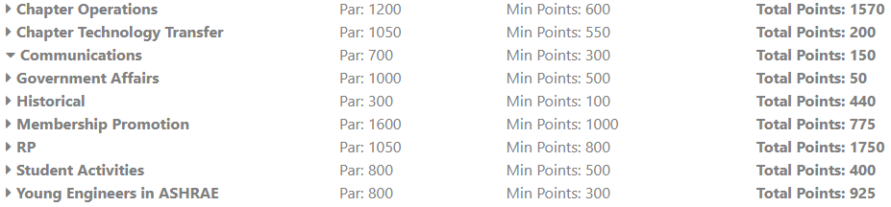 | Committee chairs, please update your PAOE numbers.  Early updates will earn you bonus points
4.0 | Other Business
4.1 | Sister Chapter with Ireland  - David Black expressed interest from Bob P.’s office
5.0 | Adjournment  Meeting adjourned at 5:40 PM | William C.
Position | EmailAlias | EmailAddress | FirstName | LastName
President | c001@ashrae.net | wcunningham@brplusa.com | William | Cunningham
Admin | c001Admin@ashrae.net | wcunningham@brplusa.com | William | Cunningham
bog1 | c001bog1@ashrae.net | allison@trumbullcampbell.com | Allison | Bookstein
bog2 | c001bog2@ashrae.net | amy.gebhardt@victaulic.com | Amy | Gebhardt
bog3 | c001bog3@ashrae.net | dadkison@f-t.com | Deanna | Adkison
bog4 | c001bog4@ashrae.net | diorioda@bc.edu | DANIEL | DIORIO
bog5 | c001bog5@ashrae.net | enorquist@f-t.com | Erica | Norquist
bog6 | c001bog6@ashrae.net | gage@trumbullcampbell.com | Gage | Foley
bog7 | c001bog7@ashrae.net | lizd@trumbullcampbell.com | Liz | Desmarais
bog8 | c001bog8@ashrae.net | nroth@neappliedproducts.com | Nick | Roth
bog9 | c001bog9@ashrae.net | srosen@f-t.com | Steven | Rosen
bog10 | c001bog10@ashrae.net | timothydriscoll@siemens.com | Timothy | Driscoll
bog11 | c001bog11@ashrae.net | wtang.ae@gmail.com | William | Tang
bog12 | c001bog12@ashrae.net | kwashle@cmta.com | Kiersten | Washle
Communications | c001CC@ashrae.net | lizd@trumbullcampbell.com | Liz | Desmarais
Alternate | c001crca@ashrae.net | wcunningham@brplusa.com | William | Cunningham
Delegate | c001crcdel@ashrae.net | dadkison@f-t.com | Deanna | Adkison
CTTC | c001cttc@ashrae.net | wfisher@fiainc.com | William | Fisher
CTTC Co-chair | c001cttcc@ashrae.net | vineet.nair@crbusa.com | Vineet | Nair
GAC | c001GAC@ashrae.net | MEpstien@centrotherm.us.com | Mallory | Epstein
ha | c001ha@ashrae.net | bob.persechini@nv5.com | Robert | Persechini
History | c001his@ashrae.net | eedman@brplusa.com | Eric | Edman
MP | c001mem@ashrae.net | kwashle@cmta.com | Kiersten | Washle
MP Co-chair | c001memc@ashrae.net | timothydriscoll@siemens.com | Timothy | Driscoll
ne | c001ne@ashrae.net | allison@trumbullcampbell.com | Allison | Bookstein
pe | c001pe@ashrae.net | vineet.nair@crbusa.com | Vineet | Nair
pub | c001pub@ashrae.net | wcunningham@brplusa.com | William | Cunningham
ref | c001ref@ashrae.net | stafone@suffolk.com | Steven | Tafone
RP | c001rp@ashrae.net | vineet.nair@crbusa.com | Vineet | Nair
RP Co-chair | c001rpc@ashrae.net | wcunningham@brplusa.com | William | Cunningham
SAC | c001sa@ashrae.net | srosen@f-t.com | Steven | Rosen
sec | c001sec@ashrae.net | lbrown@akfgroup.com | Lance | Brown
SUS | c001SUS@ashrae.net | kwashle@cmta.com | Kiersten | Washle
tr | c001tr@ashrae.net | lrowe@accuspecinc.com | Lucas | Rowe
vp | c001vp@ashrae.net | wfisher@fiainc.com | William | Fisher
web | c001web@ashrae.net | lizd@trumbullcampbell.com | Liz | Desmarais
YEA | c001YEA@ashrae.net | gage@trumbullcampbell.com | Gage | Foley

